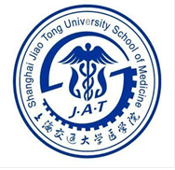

The Application Form for the JPD Program between
SJTU-SM and HUJI-Med
Applicant's Name: |  |  | Nationality: |  |  | Date of Birth:
Graduate Institution: |  |  | Major: |  |  | Graduation Date:
Home Institute: |  | £ SJTU-SM £ HUJI-Med
research interest: |  | £ Immunology £ Cancer £ Metabolism
Supervisor: ( No more than 2 PIs in each institute )
SJTU-SM |  |  |  | HUJI-Med
Name: |  |  |  | Name:
Name: |  |  |  | Name:
Proposal for Research:

